A GLOBAL PAYOUT OVERVIEW FOR:

March 16, 2015
Who Are We
Global Payout, Inc., www.globalpayout.com, headquartered in San Diego, California, is a global payments consulting company that works with organizations to develop and implement banking and payment delivery solutions around the world. Global offers off-the-shelf and customized payment options through a worldwide payment solutions platform tied to banks, card associations and payment processors Working through Global Payout's processors and banking relationships, the company provides a custom, one-stop solution for access and payments to international and domestic bank accounts, debit cards and other payment systems in more than 180 countries. The company also addresses a number of unique banking requirements by supplying payroll, personal spend, and expense reimbursement solutions to companies throughout the world. This allows employees, contractors, commissioned salespeople and vendors to be paid securely and on a timely basis. Global also supplies the backbone for many companies that deliver cross border remittance payments to beneficiaries throughout the world.

Whether operating in one country or many, Global Payout delivers a secure payment network so that Client can send payments to its workforce located anywhere in the world, in the shortest amount of time and at the lowest possible cost. Global Payout along with its partners deliver internet and mobile based payment solutions through its banking network in the currencies required by its clients. A key factor to its success is that Global Payout provides its client with solutions tailored specifically to its business requirements, through secure and compliant technologies recognized worldwide.

The Cost
The information below is simply a general base pricing table for this preliminary proposal. This pricing will be refined as we more clearly define and understand the total requirements of the company on a global basis.

GLOBAL PAYOUT
MONEYTRAC® PREPAID MASTERCARD

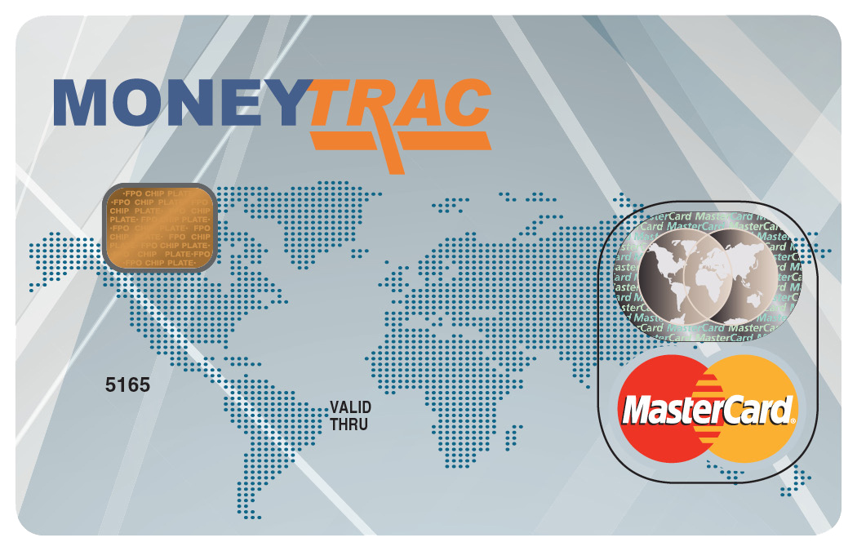

MasterCard – This is a Chip and PIN Prepaid MasterCard from Global Payout’s partner bank in the Caribbean.
Global - The cards can be issued to residents of most countries in the world.
Full Function - Cardholders can do ATM withdrawals for cash, online purchases, purchases at restaurants and merchant locations everywhere MasterCard is accepted.
For Groups - As required by MasterCard, the Global Card can only be issued to members of groups and affiliations, such as:
- Employers and MLM companies - The Global Card is an excellent payroll and payout card for businesses with employees from many different countries.
- Affiliation & Customer Groups – Such as Shopping clubs, remittance & money transfer and micro-financing companies.
- Payouts - Of Insurance, dividends, Incentives/Rebates, etc.

Money Transferring and Card Loading:
- Money Transferring – The Group wires funds to the issuing bank for future card loading
- Card Loading or API – Card loading can be processed via API or through batch files sent to the Program Manager (Global Payout) 48 hours in advance of the payroll load date.
- Instant Loading - Through card-to-card transfer on the Web.

Card Account Review – Cardholders can view their individual account balances and activities on the Web.
Fees & Costs:
Description | Cardholder Fee
Administration
Activation Fee | $2.00
Monthly Account Fee | $3.95
Transactions
POS Purchase | $1.00
POS Purchase International w/ FX Conversion | $1.25
POS Purchase Declines | $0.50
ATM Cash Withdrawal | $3.20
ATM Balance Inquiry | $1.75
ATM Declines | $1.75
Bank Counter Cash Withdrawal | $3.20
FX Conversions | 2.50%
Card to Card Transfer | $2.00
Card Reload | $1.00
Customer Support
IVR Support /Call | $0.10
Live customer Support /Call | $1.00
Web Banking | Free
Card Chargeback Fee (if not acceptable) | $25.00
Delivery
USA SINGLE per delivery | TBD
USA BULK per delivery | TBD
USA SINGLE EXPEDITED per delivery | TBD
USA BULK EXPEDITED per delivery | TBD
INTERNATIONAL SINGLE per delivery | TBD
INTERNATIONAL BULK per delivery | TBD

Program Start-Up & Implementation Fee:
Description | Fee
Bank and MasterCard Due Diligence Review; Account Set-Up | $5,000.00
Generic Programming Fee For Each Company Client (Non-Refundable):
- Bank and MasterCard Due Diligence Review
  - Program Qualification, Risk Assessment, Profiling and Due Diligence, Program Scope, and Implementation.
- USD Sub BIN Assignment
  - Technical Implementation and Management
  - Client Corporate Funding Account Set Up
  - Client Corporate Account Management Access
- Client Program Training
  - Risk Management Assessments and Due Diligence
  - Card Holder Online Account Management
- Monthly Reporting

Co-Branding Fee:
Description | Fee
Custom Branding and Co-Branding Card Program | $5,000.00
The Review and Approval Process Takes Between 90-120 Days With A Minimum Order Requirement Of 10,000 Units.
Company Branding Fee For Each Client:
- Card Manufacturer
  - Artwork Proof Design Based on Client Specifications
  - Fulfillment and Storage of all Branded or Co-Branded Card Plastics and Collateral
- Bank and MasterCard Review and Submission
  - Company Logo and Card Background Design Approval
  - Branded Collateral Approval

Card Costs:
Card Production Bands (Quantity) | Client Pricing  (Cost Per Plastic Card)
1,000 – 19,999 | $6.95
20,000-49,999 | $6.45
50,000-99,999 | $5.95
100,000+ | $5.50
Note: Cardholder pricing to be determined by client.

Card Characteristics:
Description | USD Denomination
Maximum Balance – Monthly | $10,000.00
Max ATM Withdrawal – Daily | $1,000.00
Max POS Purchase – Daily | $2,500.00
Max Load – Daily | $10,000.00
NOTES
- Card Activation Fee is a one-time fee. Cardholder pays Activation Fee upon initial loading. Client Company will be invoiced for cards that are Activated but not loaded within 90 days. All cards not loaded within 90 days are subjected to closure.
- Cards can be shipped in bulk or individually, with which the individual cardholder pays shipping.
- Know Your Customer “KYC” information must be collected (with an image uploaded or emailed) and successfully verified in advance of each card account Activation.
- All loading will be done via transfer from Client to a designated Card Program Funding Account setup for the program. Clients must maintain a reserve account sufficient to provide real time account loading or loading will be subject to loading within a 24-hour period if funds are received by 5pm GMT on a weekday.
- Pricing subject to change prior to agreement approval or if dictated by Association or Issuing Bank during term of Agreement.
- All fees quoted are in USD ($)
- The Monthly Maintenance fee per card only applies to cards that have been activated
- Monthly Minimum Billing after 90 days of service:
  - Months 4+ = $2,500 or a minimum of 250 active cards*

*Active card: A card with an active balance or with at least 1 transaction within the last 90 days.

